Merge Implementation:
Before Implementation – Count and Samples:
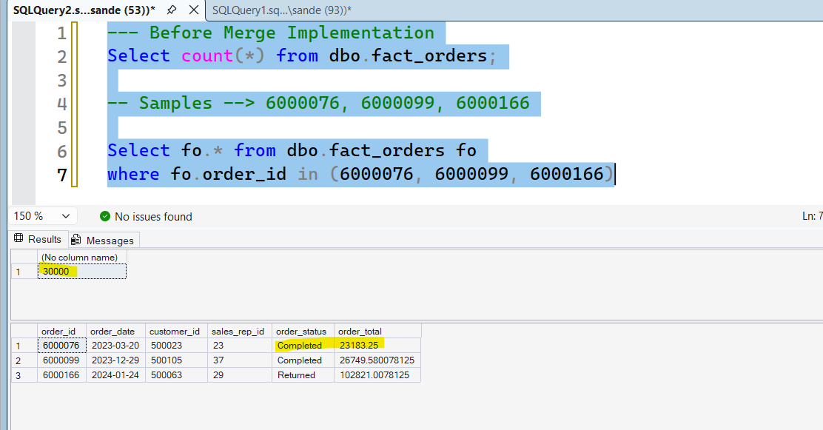

POST Implementation:
